West Boise Needs Your Support

The Boise Library wants to expand library access. We’d like the city to know that citizens across Boise support equitable library access. Can you take a few minutes to join our petition?

To sign, visit: <https://citizensforalibrary.org/west-boise>

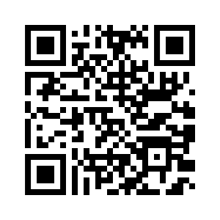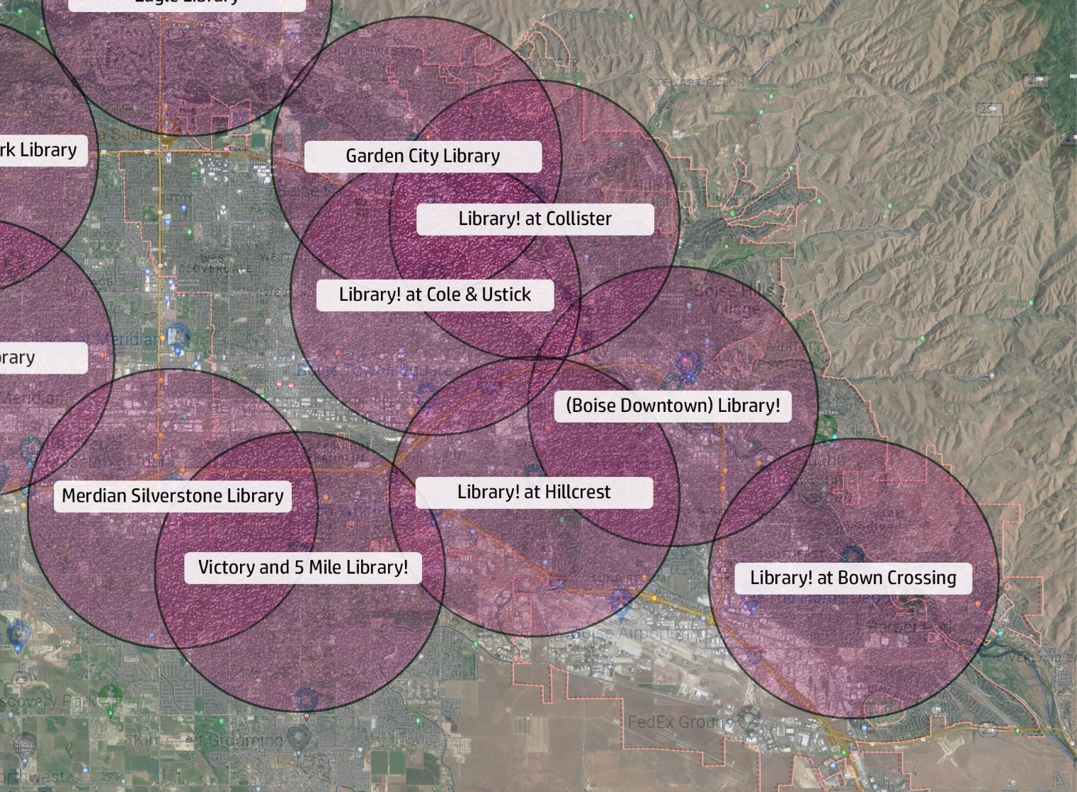

West Boise Needs Your Support

The Boise Library wants to expand library access. We’d like the city to know that citizens across Boise support equitable library access. Can you take a few minutes to join our petition?

To sign, visit: <https://citizensforalibrary.org/west-boise>



We’re a group of citizens who believe that city libraries are a valuable resource that Boise citizens should have equitable access to.  The Boise Public Library wants to expand access, and we would like to request that West Boise is not overlooked.  Will you please join us in signing a petition to the Mayor and Boise City Council?

Sincerely,

*Citizens for a Library in West Boise*

<https://citizensforalibrary.org/west-boise>

The **Centennial Neighborhood Association**supports the need for Boise to have a library closer to the citizens of West Boise and believes that the addition of a library, more accessible to its residents, will help to fulfill Centennial’s stated goal of making west Boise “a better place to live, to work and to raise a family.”

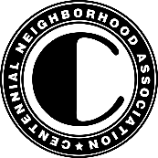Gary Dufault, President

Centennial Neighborhood Association

[www.centennialna.org](http://www.centennialna.org/)

Dear West Boise Neighbor:

We need your help! It's time our residents have equal access to library services. Please join me in fighting for library access at City Council. By signing this petition, you'll show that West Boise matters!

Luci Willits

Boise City Council

District 1

My Contact Info

Name: ________________________

Phone: ________________________

Email: ________________________

We’re a group of citizens who believe that city libraries are a valuable resource that Boise citizens should have equitable access to.  The Boise Public Library wants to expand access, and we would like to request that West Boise is not overlooked.  Will you please join us in signing a petition to the Mayor and Boise City Council?

Sincerely,

*Citizens for a Library in West Boise*

<https://citizensforalibrary.org/west-boise>

The **Centennial Neighborhood Association**supports the need for Boise to have a library closer to the citizens of West Boise and believes that the addition of a library, more accessible to its residents, will help to fulfill Centennial’s stated goal of making west Boise “a better place to live, to work and to raise a family.”

Gary Dufault, President

Centennial Neighborhood Association

[www.centennialna.org](http://www.centennialna.org/)

Dear West Boise Neighbor:

We need your help! It's time our residents have equal access to library services. Please join me in fighting for library access at City Council. By signing this petition, you'll show that West Boise matters!

Luci Willits

Boise City Council

District 1

My Contact Info

Name: ________________________

Phone: ________________________

Email: ________________________